Central Broker Demo

User Experience Walkthrough and Storyboard to illustrate how the central broker demo works and the expected user journey.

**Table of Contents**

Introduction 3

Solace Broker Set-Up 3

Site Flow 3

User Interface Walkthrough 4

Agency User 4

Login Page 4

Home Page 4

Published Topics 5

Topics Available 5

Current Message Statistics 5

Register a Topic 5

Analytics and Mapping 6

Central Broker Administrative User 6

Analytics and Mapping 6

# Introduction

The central broker assists in the smooth transfer of data between multiple different agencies. It is a solace events broker that can be utilised to create bridges with other solace brokers of other agencies, and through the use of Client and ACL profiles, different agencies can then exchange and share data in a secure, central and easy manner.

## Solace Broker Set-Up

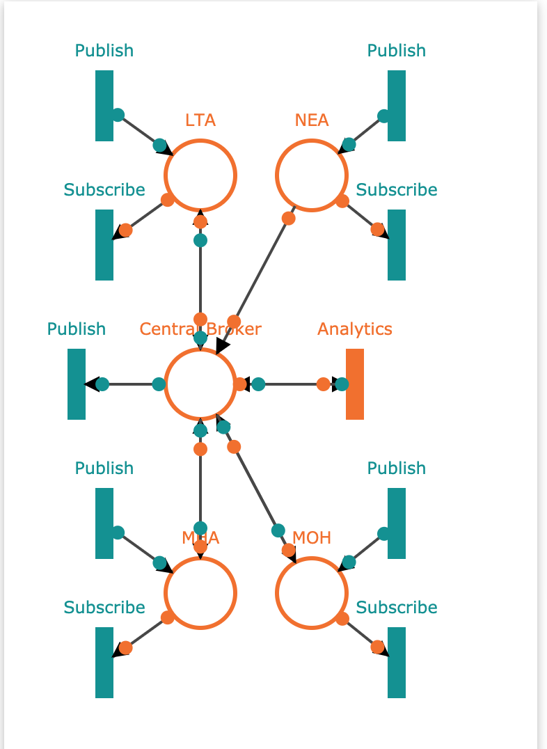

## Site Flow



User Interface Walkthrough

## Agency User

1. Works in an agency (NEA, LTA etc.)
2. Interested to see what data is available to them and to share data to be used by other agencies

### Login Page

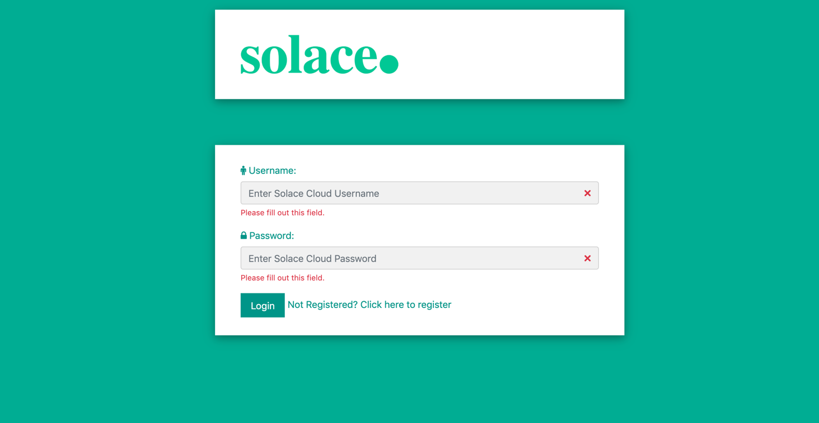

### Register

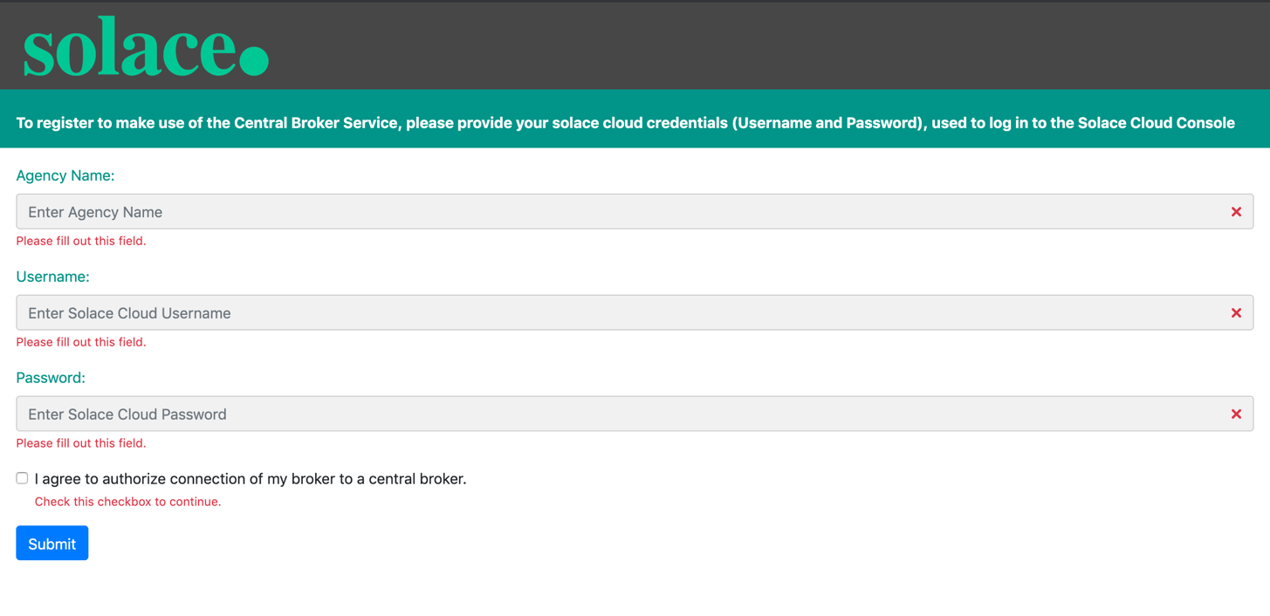

### Home Page

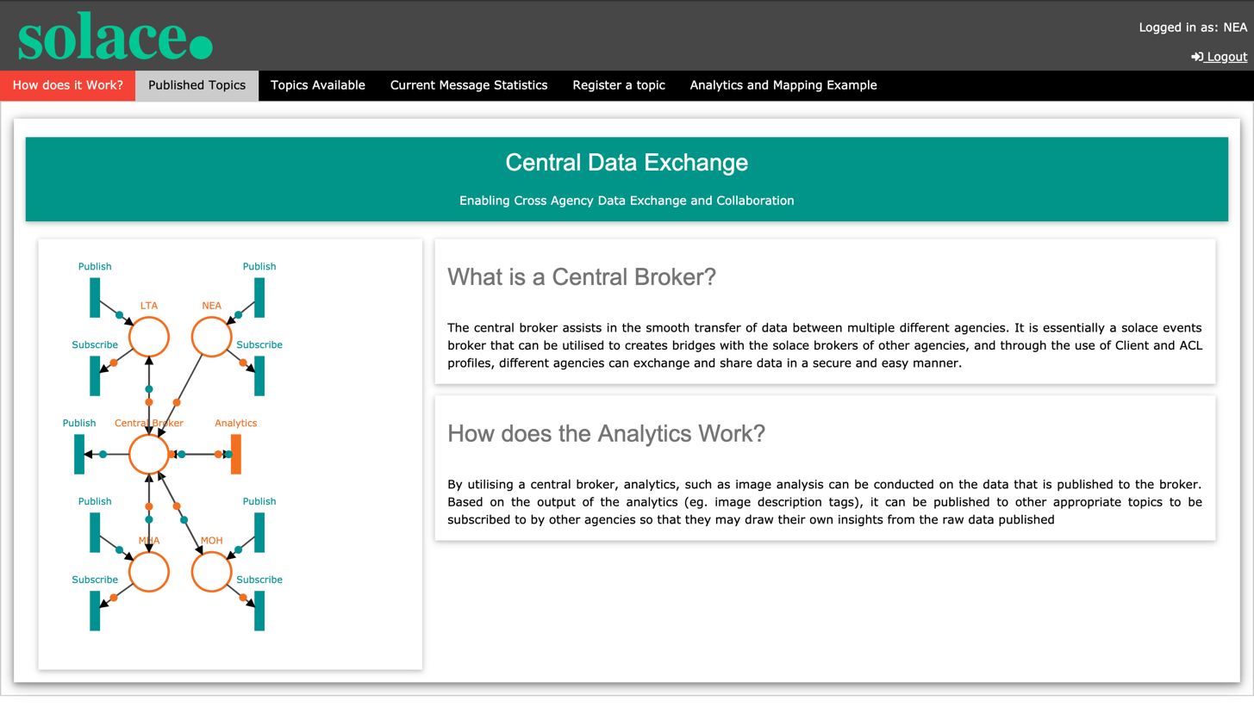

### Published Topics

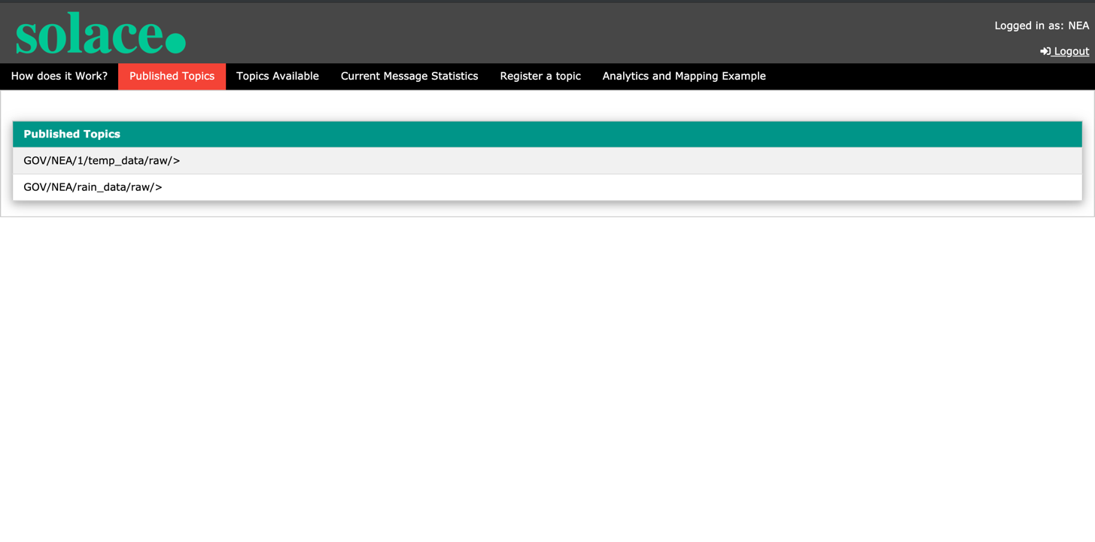

### Topics Available

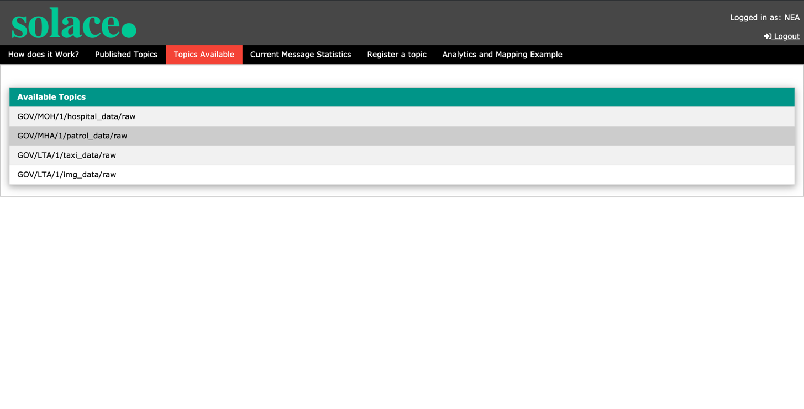

### Current Message Statistics

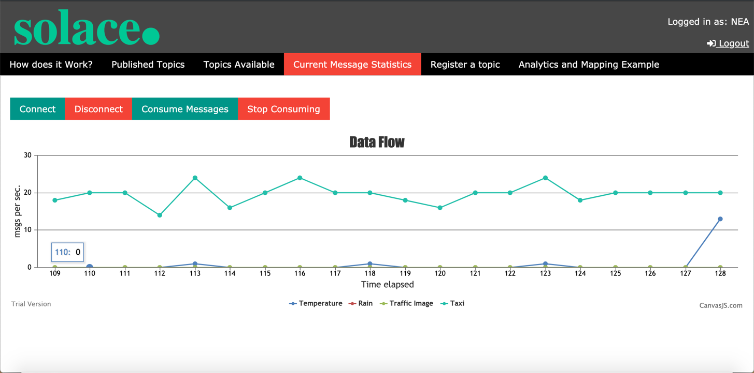

### 

### Register a Topic

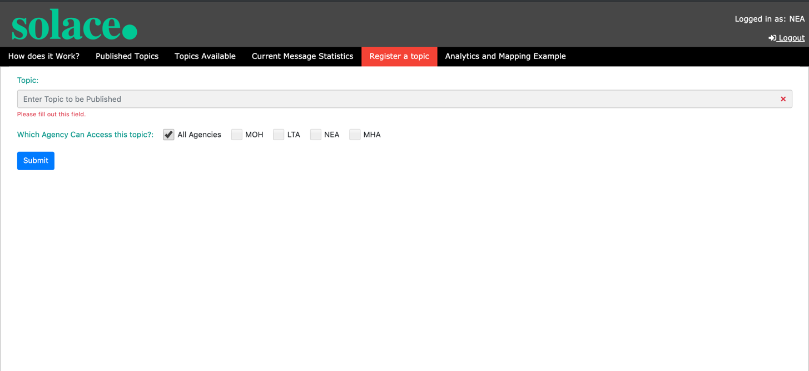

### Analytics and Mapping

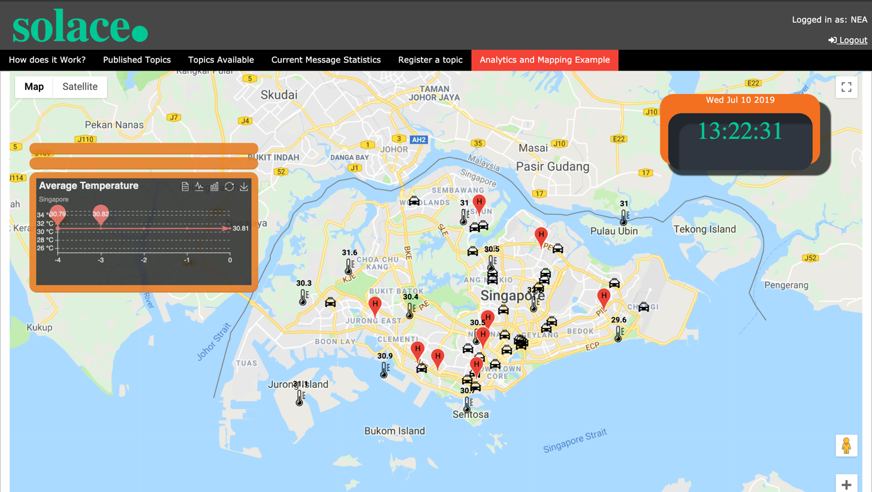

## Central Broker Administrative User

1. Runs and maintains the central broker
2. Configures and sets up new connections to be

### Message Log

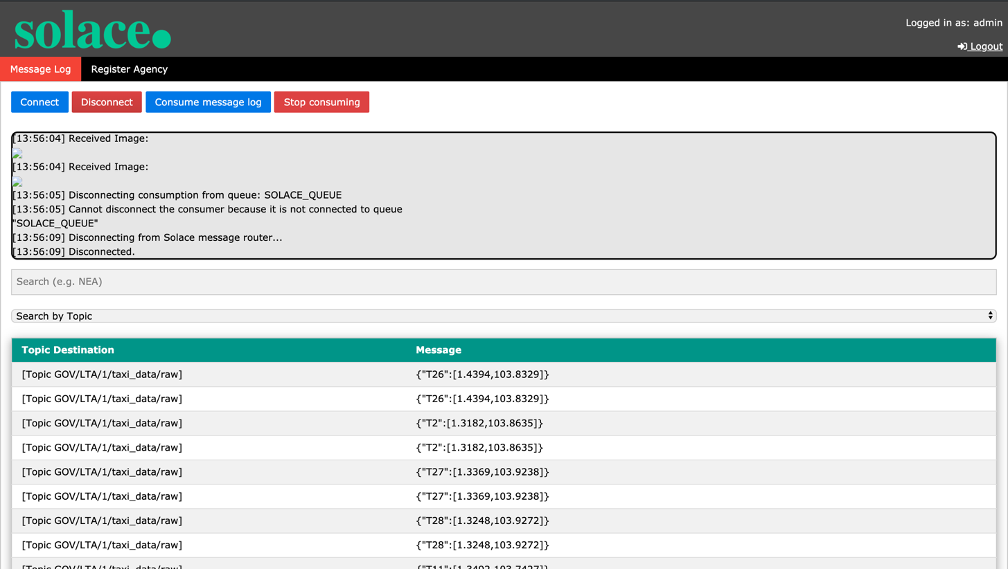

### Register Agency

